**KAMPALA JUNIOR ACADEMY**

**P.1 ENGLISH TERM I 2020**

NAME: ___________________________________________STREAM: _______

**WEEK ONE**

1. Change these words to capital letters.

a) book _______________ (b) window ______________

c) chair _______________ (d) table _____________

2. Change to small letters.

a) MOTHER _______________ (b) BROTHER _____________

c) SISTER ______________ (d) UNCLE _______________

3. What is this?

a) This is a book.

b) What is this?

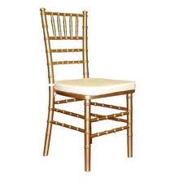 __________________________________

c) What is that?

__________________________________

4. Change these words to action words by adding ‘ing’

a) read _______________

b) dance ________________

c) write ________________

d) play ________________

e) mop ________________

5. Arrange these words in **abc** order.

a) cup, plate, table

________________________________________________________

b) flag, chalk, ruler

_______________________________________________________

c) book, duster, pencil

________________________________________________________

6. Write the opposite of the underlined word.

a) My father is sick.

________________________________________________________

b) She has a good book.

________________________________________________________

c) That pencil is small.

________________________________________________________

7. Write these sentences correctly.

a) book my is That.

_______________________________________________________

b) name What your is?

_______________________________________________________

c) a good cup has She.

________________________________________________________

d) woman a is She.

_________________________________________________________

8. Make correct sentences from the table below.

|  |  |  |
| --- | --- | --- |
| He  I  She  They  We  Nakato  Musoke | is  are  am | reading a book.  pulling a goat.  playing.  running. |

a) _________________________________________________________

b) _________________________________________________________

c) _________________________________________________________

d) _________________________________________________________

e) _________________________________________________________

f) _________________________________________________________

9. Fill in **a** or **an** to complete the sentences.

a) I have _________apple.

b) It is __________red ball.   
c) We have ________big table.

d) __________elephant is a big animal.

10. Write these nouns in plural.

a) chair _________________

b) table _________________

c) box ___________________

d) stone _________________

e) stick __________________

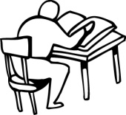11. Make correct sentences for the pictures.

a)

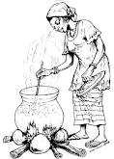 ________________________________________________

b)

_______________________________________________

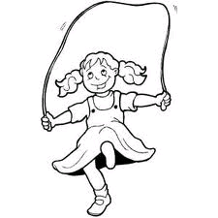

c)

_______________________________________________

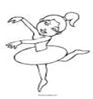d)

_______________________________________________

12. Use **Yes, it is** or **No, it is not**.

a) Is this a book?

________________________________________

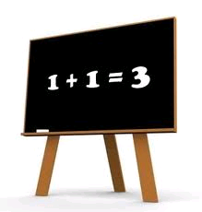

b) Is this a blackboard?

________________________________________

c) Is this a ruler?

________________________________________

d) Is this a chair?

_________________________________________

13. Write out the verbs.

a) He can dance. ______________

b) Mary is cooking food. _________________

c) He eats a lot of food. ___________________

d) We are digging in the garden. ________________

14. Make one word by joining two underlined words.

a) A cloth for the table is a _________________________

b) A man who brings milk is a ________________________

c) A bell for school is a _______________________

d) A vase for a flower is a _____________________

e) A pot for tea is called a __________________________

15. Complete the table below.

**Animal Young one**

cow _________________

cat _________________

lion _________________

______________ fry

goat ___________________

bird __________________

16. Punctuate correctly.

a) Show me a book

______________________________________________________

b) wednesday comes before thursday

______________________________________________________

c) today is monday

_________________________________________________________

d) i live at mengo

_________________________________________________________

17. Complete the sentences correctly.

a) Start is to begin as top is to ________________.

b) A cat is to _______________as a cow is to calf.

c) A driver is to car as a _____________is to aeroplane.

18. Re-arrange the jumbled words to form sentences.

**e.g.** **Parents care take of children their.**

**Parents take care of their children.**

a) children sweep to help compound the

________________________________________________________

b) food buy Father helps to

_______________________________________________________

c) school fees help parents Our to pay

____________________________________________________

d) Mother food helps to cook.

_______________________________________________________

19. Read the story and answer the questions that following full sentences about family roles.

Our father is the head of the family. He pays school fees, provides security and buys food for the family members.

Mother takes care of us by cleaning the house, cooking food and washing clothes. Children wash the dishes sweep the compound, fetch water care for the babies.

Our parents teach us good morals.

**Questions**

a) Who is the head of the family?

________________________________________________________

b) What does mother do?

i) mother _______________________________________________

ii) mother _______________________________________________

c) Who pays school fees for the children?

________________________________________________________

d) Draw yourself helping at home.